###### **50 Springfield Street, Providence, RI 02909**

***Tel. 401.278.0554, fax 401.278.0556***

[***http://www.providenceschools.org/carnevale***](http://www.providenceschools.org/carnevale)

***Mari-Ellen Boisclair – Principal***

***Kimberly-Ann Zona – Vice Principal***

Student of the Month

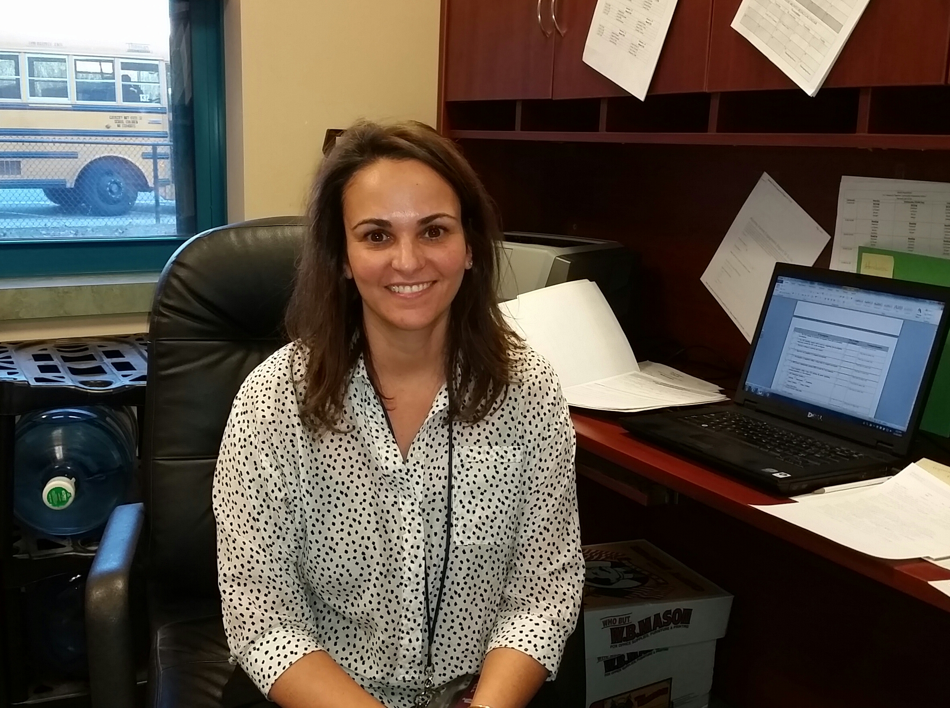

**October 2015**

Interview with Mrs. Zona by Room 213

**How long have you been an educator?**

*I have been teaching for 15 years.*

**Why did you decide to become a teacher/administrator?**

*I wanted to be able to help students as much as possible.*

**Where did you go to school to become a teacher/administrator?**

*I attended Providence College.*

**Have you only taught in the Providence school system?**

*Yes, I taught 3rd grade at Webster Avenue School*

**What is your favorite subject?**

*Reading is my favorite subject.*

**What is the best thing that you like about your profession?** *The best thing is I get to see kids every day!*

205 Wisdom Silva

206 Zabdi Castillo

207 Devan Khoun

210 Luis Pagan

211 Abednego Bleh

212 Brenden Rosales

213 Musta’an Mogaji-Oleolo

214 Jasmine Morales

215 Alexis Hathaway

216 Eakapon Phothisen

217 Yuridia Perez Gamarro

219 Alexa Rodriguez Villatoro

PE-1 Giovany Guzman

PE-2 Juan Ortiz

PE-4 Damien Devine

Art- Nathaniel Smith

Music- Chace Culpepper

101 Jayden Godoy

102 Mia Vasquez-Barruti

103 Rayanna Rosario

104 Jerry Dean Hall

105 Giovany Guzman

106 Sophia Rodriguez

107 AmberLee Garcia /

Gianna Segura

108 Eduardo Monji-

Calderon

109 Nathan Acosta

110 Egyptian McKie

111 Isaac Villar

112 Elijah Prak

113 Eric Taylor

114 Angelo Barrientos

Morales

201 Amanda Jimenez

202 Darren Guzman

203 D’Mauri Bonds

204 Jeremy Esquivel Vargas

Brown

*How long have you been teaching?* 16 years.

*Why did you decide to become a teacher?*

*Where did you go to school to become a teacher?*

*Have you only taught in the Providence school system?*

*What is your favorite subject?*

*What is the best thing that you like about your profession?*

*What would you tell a student who is thinking about becoming a teacher in the future?*

*What town do you live in?*  *Are you married?*

*Do you have any children?*

*Do you have any pets?*

*What type of music do you listen to?*.

*What do you watch on T.V.?*

***\*Student of the Month for September is listed and /or pictured on the school’s web page!***

Upcoming Calendar of Events!

November 2015

11/17- 11/18/15 Parent Conferences **@ 4-6 p.m. with teachers.**

**11/19/15 Carnevale Dancers @ Del Sesto Middle School**

11/26 – 11/27/15 **NO SCHOOL** (Thanksgiving )

**December 2015**

12/5/15 Breakfast with Santa @ 9 am

12/7/15 Choral Concert - State House 10:30 a.m.

**12/17/15 Winter Choral Concert @ 6:30 p.m.**

12/21/15 – 1/3/15 **NO SCHOOL** (Holiday Break)

**January 2016**

1/4/16 **Students Return To School!**

1/18/16 **NO SCHOOL (Martin L. King Day)**

1/29/16 **2nd Quarter Ends**

Publishing Committee

**Any questions or comments about this publication can be address to the following teachers at the school:**

*Robert Maher, Kristen Mariniello, Dina Cochrane,*

*Ronald Enos, Mary Makillop, Melissa Lautieri, Kara DeFlorian, Lisa Airhart, Susan Connole, Dina Lombari, and Kelly Johnson.*

***“As a Feinstein Leadership School we are committed to teaching our students to be caring of others.”***

**Art News – Ms. DeFlorian**

The **Feinstein Junior Scholar Artists** at ACE have been exploring different mediums in Art. We explored painting, collage, and mixed media Starry Night pictures made in Room 202. Also room 216, Fifth grade, assembled accordion, pop-up Starry Night pictures.  Below are photos for your enjoyment! (*More Pictures On page 4!)*

Artwork pictured below by: Rufus in room 202

**Notes from Nurse –**

**Mrs. Anderson RN:**

HAPPY FALL

With colder weather more illnesses occur. It is important that parents or an emergency contact can be reached if your child should become sick. Please make sure all emergency phone numbers are up to date. Please send any changes to school immediately.

**WHEN TO STAY HOME**

While attendance at school is important to your child’s success, there are certain times that your child should stay home. They are as follows:

-***An increase in symptoms of coughing, sneezing or runny nose (especially if nasal drainage changes color from clear to yellowish-green).***

***-Any fever, (before returning to school, children must be free of fever for 24 hours without the use of any fever reducing medicines, such as Tylenol or Motrin.***

***-Vomiting and/or diarrhea, your child should be tolerating their regular diet, before returning to school.***

You know your child best of all. Please use your own judgment if you feel your child should stay home even when they want to come to school. Please don’t hesitate to call me for any questions!

**Our Great Kids:**

Parents and students be sure to watch ***Our Great Kids’*** on Saturday and Sunday at 10:00 am on PBS channel 36 and Cox channel 8 on your televisions!

**Physical Education/ Health News-**

**Ms. Mariniello, Mr. Payne, Mr. Enos, and Mrs. Denton-Pichie**

Welcome back from the Carnevale PE Department. We have begun our first unit. Third - Fifth Graders are working on communication and cooperative games and will begin Volleyball after the Thanksgiving Holiday. Kindergarten - second graders are focusing on locomotor skills, levels, tempo and pathways and will begin riding scooters after Thanksgiving.  We look forward to growing stronger and healthier throughout the year.

**Dance Program:**

The Carnevale Dancers, which is made up **Feinstein Junior Scholars**, will be performing in a show at Del Sesto Middle School Cafetorium on Thursday, November 19th. All ticket sales will be donated.

**Music News – Mr. Maher**

Once again, our choral group was invited to perform at the State House on December 7th at 10:30 a.m.

Our annual **Winter Concert** will take place on December 17, 2015 in the school’s gymnasium at 6:30 in the evening. There will be performances by the both the Chorus (grades 3-5) and Junior Chorus (grades 1&2). The concert is free and all are welcome to attend. A brief reception will follow the concert.



Our annual Harvest Dance was held on October 22nd with the YMCA’s Lights on after school event. *The next* ***Student of the Month*** *Presentations will take place on* ***November 25, 2015*** *at 8:30m!*

**Recycling Program**

**A message from – Mrs. Airhart**

We are excited to announce that Anthony Carnevale Elementary School is starting a waste and disposal program with the help of the RI Resource Recovery Corporation. The following will take place to support this program.   There will be recycling presentations with MaxMan for grades Kindergarten thru grade 5.  Recycling bins will be placed in all classrooms. A student-led recycling station will be set up in the cafeteria to maximize recycling of lunch items.  **Feinstein Junior Scholars** from grades 4 and 5 will be visiting the landfill complex to see firsthand where their garbage goes after it leaves the curb and also get an up-close look on how the recyclables are sorted and made ready for the market. Finally, there will ongoing education in the classroom.

**Classroom & Field Trip News:**

**Third Grade** **Feinstein Junior Scholars** went to the Arnold House located in Lincoln, RI.  This is an historic house of colonial times.  We did four activities: candle making, bartering, colonial games and colonial school.  It was a fun educational experience that brought Social Studies to life!

**Second Grade** **Feinstein Junior Scholars** made parachutes while studying Air in Science.  Sophia and Ms. DePedro tried out the parachutes to see if air would keep them afloat.

